Wood Properties

Introduction

“We may use wood with intelligence only if we understand wood.”

Frank Lloyd Wright (The Cause of Architecture: Wood The Architectural Record, May 1928)

Wood is such an omnipresent material with a very lengthy history of use that sometimes it is taken for granted. However, wood is a very complex, natural material that is actually a composite with some unique characteristics. Some of the uses of wood require no knowledge by the end-user of wood’s properties. Other uses of wood are much more technical and require detailed knowledge of the scientific characteristics of the material. This is particularly true if the wood is to go through various manufacturing processes. The greater our understanding of wood, in terms of its structure and its properties resulting from that structure, then the greater is the chance of us utilizing this natural resource closer to its full potential.

Origin of Wood Properties

It is important to remember the natural origin of wood - wood is produced by a tree for its intended end-uses and not for ours. The two main functions that wood performs in a tree are those of mechanical support of the crown and the transport of water and nutrients. The wood in the tree’s trunk supports the crown of the tree so that it can maintain its position over shorter plants to capture more sunlight enabling photosynthesis to occur in the leaves. It also provides a route for the transportation of water and dissolved nutrients from the soil to the leaves. Its structure is designed for self-preservation and growth.

Wood is cellular in nature and different types of cells perform different functions in the living tree. The particular cells present and their arrangement differ from tree to tree. These differences help us to identify different types of wood. The cell wall contributes to the mechanical support function of the wood while the cell cavities contribute to the transportation (or conduction) function. Since both the mechanical support and conduction functions are required in the direction of the height of the tree, most of the cells (which can be thought of as narrow straw or tubes) are oriented in that direction.

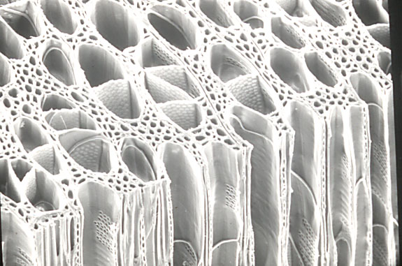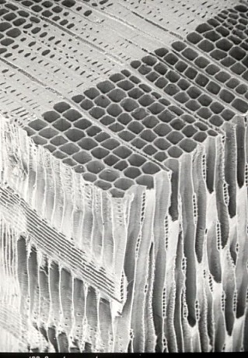
a
b

Figure 1. Scanning electron micrographs of (a) a hardwood (Trembling aspen) and (b) a softwood (Douglas-fir). (W.A. Côté)

The tree did not anticipate its trunk being sawn into dimension lumber or being pulverized in a mechanical pulping process to make newsprint. The tree produced wood to perform particular very important tasks necessary for its growth and continued wellbeing. Man applies wood in situations where some of the characteristics imparted by its inherent structure might not suit our applications. It is up to us to understand the properties of the wood and to utilize it to the fullest of its potential and seek ways to alleviate some of the detrimental characteristics as we deem them.

The properties of wood can be explained by features or levels of structural variation found at four different levels. These four levels are:
- Macroscopic – features visible with the naked eye
- Microscopic – features visible with a light microscope
- Ultra-structural or nano-structural – features sometimes visible with an electron microscope
- Molecular or chemical – features not generally visible by any current microscopic visioning system.

Since wood is used in an extremely wide variety of applications, it can be difficult to state generally what are the positive and negative attributes of wood as a material since one property may suit one end use well but be detrimental to another end use. However, in the context of the use of wood as an industrial raw material (either alone or in combination with other materials), the following discussion attempts to group wood properties into those which are generally viewed as being positive, those generally viewed as being negative, and those which differ depending on the particular end use.

Positive attributes

Renewability
Wood is a natural renewable material. It is produced by a living organism capable of reproducing itself. As long as we act in a responsible manner when harvesting trees, productive forest land should be capable of producing multiple crops of trees for an indefinite period. There is increasing debate as to whether or not continued harvest of trees from a site will eventually deplete the site of its nutrient resources due to the shift towards industrial tree plantations as a growing source of trees.

Variety
The variety of wood species found worldwide is truly remarkable and contributes to the wide variety of uses for wood. No one wood species is suitable for all end-uses. For example, the hardwoods used to produce fine furniture may not necessarily produce good quality chemical pulp or dimension lumber for construction while the softwood species used for structural lumber in North America may not be suited to application as marine pilings for boat wharfs or pulp for absorbent papers.

Workability
Wood is an extremely versatile material with which to work. It can be processed or worked by a wide variety of tools and machines. These machines range from large-scale industrial machines, through smaller scale power tools to simple hand tools. Thus, wood can be processed on an industrial scale for the mass production of products; it can also be used for commercial construction purposes and yet can still be used by the home hobbyist. Wood can be sawn, planed, sanded, drilled, moulded, or routed. Wood pieces can also be joined by nails, screws, bolts, connectors or adhesives.

High specific strength and stiffness
For its weight, wood is a remarkably strong and stiff material. This property is due to the cellular nature of wood. The distribution of cells i.e. a system of long thin hollow tubes, is a very efficient use of the cell wall material. The term “specific” here refers to a comparison on a weight-to-weight basis. It is not claimed that a 2x10 floor joist made of wood is stronger than the same dimension joist made from steel. However, a given weight of wood is able to withstand a greater load than a member made from the same weight of steel.

Environmental impact
The public perception of the environmental attributes of wood as a building material has often been overshadowed by negative images of past, poor harvesting practices. However, life cycle analyses (LCA) have demonstrated that wood leaves a much smaller environmental footprint that steel or concrete. LCA was discussed in the first module. Wood products have a smaller environmental impact than steel and concrete with respect to: energy consumed in production, greenhouse gas emissions, air-borne pollutants generated, water pollution and solid waste production. For full information on LCA for building materials see the web site for the Consortium for Research on Renewable Industrial Materials (CORRIM) at http://www.corrim.org/

Insulation
Wood is a good insulator (or conversely a poor conductor) of heat and electricity due to its cellular arrangement. In lumber the cavities of the wood cells are filled with air. These air pockets do not conduct heat very well and sit trapped in the structure of the piece of wood. Denser woods tend to be poorer insulators since there the air to cell wall ratio is smaller (think about whether you would like to sit on a bench of red oak or western red cedar in a sauna!). Greater amounts of moisture in the wood will also increase the conduction through the wood since water is a much better conductor of heat and electricity than is cell wall material.

Buoyancy
Most wood floats in water, because the density of the piece of wood is less than the density of water. Actually the substance that makes up the cell wall is denser than water (approximately 1.5 g/cm³ compared to 1.0 g/cm³) but a piece of “solid” wood is actually not all solid material. Much of a piece of wood is made up of air spaces in the cell cavities also called lumens. Most softwoods have an air-dry density of about 0.30-0.40 g/cm³. This density indicates that only about ¼ of the volume of the piece of wood is actually occupied by cell wall material while approximately ¾ is occupied by air. While hardwoods have a greater range of density values, most of them have air-dry densities below 1.0 g/cm³. Some hardwoods can attain an air-dry density of greater that 1.0 g/cm³ (and thus will sink in water) but these species tend to be the exception rather than the rule.

Toughness
Due to its energy-absorbing properties, wood is very good at resisting impact loads. The numerous interfaces between the wood cells and their orientation provide means of conducting energy away from the point of impact on the wood’s surface. Together with its excellent vibration-damping characteristics, this toughness of wood makes it well suited to applications where dynamic (changing) loads are experienced.

Aesthetic/psychological appeal
Wood has an undeniable, inherent “feel” to it which few, if any, other materials can match. This “feel” is both physical and sensual in nature. While the psychological appeal of wood is inherently subjective to each individual person’s personal taste and experiences, the natural origin of wood generally tends to impart certain feelings or emotions that make us feel comfortable about or sympathetic towards wood and wood products.

Negative attributes

Variability
Since wood is a natural, biological material there is an inherent degree of variability of a particular property or parameter that will be found from one piece of wood to another. This variability is not the same as the variety between species discussed earlier. Variety can be thought of as the differences between species of wood. Variability is referred to in the context of one species of wood being assessed for one particular use. This variability is detrimental to wood attaining its full potential for use since the average value of a particular property of a population of wood samples cannot be used but rather some lower value to ensure safety or comfort. For example, allowable stress values which used to be calculated for incorporation in structural design calculation could not be based on the mean (average) value of a group of tested samples. Instead, the lower 5th percentile (the value below which 5% of the population falls) has been used as the starting point and then additional safety factors are subsequently applied. Often these lower percentile values are significantly lower than the mean value and the material is greatly under-utilized. The less the variability of a population, the closer the lower percentile values will be to the mean value and thus the more optimal utilization of the material can be achieved. For example, MSR lumber reduces the variability and improves the utilization of lumber for structural purposes.

Anisotropy
Wood is anisotropic in nature. In other words, it is possesses different properties when measured in the three major directional axes that result from the structure of wood (Figure 2). Anyone chopping kindling from a larger piece of wood knows to split the wood along its grain first to break the wood into smaller pieces. Chopping the wood across the grain requires much more effort. Another example is the permeability of wood that can be as much as 100 times greater in the longitudinal direction (parallel to the grain) than in either transverse direction (perpendicular to the grain). Anyone who has painted wood has experienced this phenomenon since the end grain of a piece of wood (where the open ends of the cells are exposed) will take up much more liquid paint than the sides of the same piece of wood. Also, the compressive strength of most woods is about 5-7 times greater parallel to grain than perpendicular to grain. In this case the cells are stronger when compressed along their length as compared to squashing them from the side.

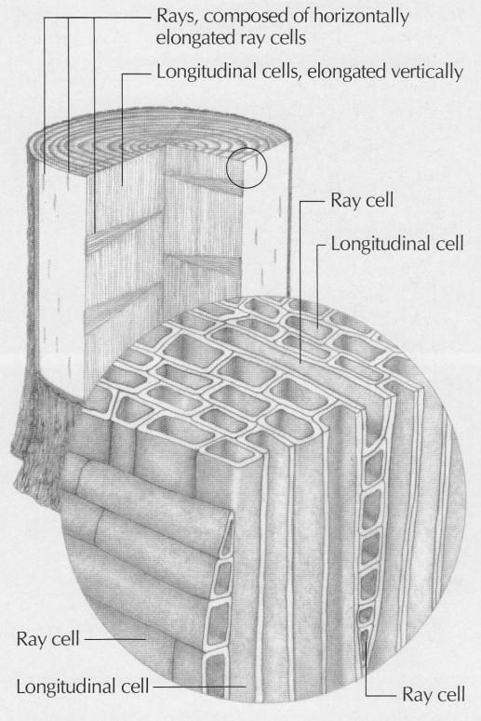

Figure2. Anisotropic nature of wood, illustrating the distinct wood planes and grain orientations. (Hoadley)

Hygroscopicity (ability to absorb water from the air)
Wood is in a constant state of dynamic equilibrium with the water vapour in the surrounding air. This interaction with water vapour is due to the chemical nature of wood’s cell wall components. Wood contains polymers containing a number of chemical functional groups though which water vapour molecules can attach by hydrogen bonds. There is a natural tendency for the wood to take up moisture from the atmosphere when the surrounding air is relatively moist compared to the wood and to lose moisture to the atmosphere when the air is in a relatively dry state compared to the wood. These processes are both reversible such that the moisture content of a piece of wood is constantly changing to match the conditions in which it is situated. The amount of water in wood has a profound effect on many of woods properties including its weight, dimensions, insulating ability, strength, workability, and combustibility.

Biodegradation
Wood can rot as a result of fungal or bacterial action and it can also be degraded by insect attack. In the biodegradation of organic material, there are four primary factors that the degrading organisms require for their destructive action to occur: a source of oxygen, temperature within a certain range, an adequate supply of water and a source of food.

Wood provides the food sources for some of these degrading organisms. These compounds can include soluble sugars, certain extractive material or the cell wall substance itself. However, eliminating any one of the four factors mentioned above can control the biodegradation of wood. Some wood submerged in water for long periods of time show no fungal degradation because of the absence of oxygen. Temperature control is also difficult and while wood can be pasteurized or sterilized by heat treatment, this treatment does not prevent the wood from re-infestation and attack at a later time. By drying wood to a point below a particular moisture content and ensuring that it stays in this condition, the degradation of wood can be eliminated by depriving the organisms of their required water. Lastly, the food source (the wood) can be poisoned. This is the approach taken by wood preservation. Chemicals, which are toxic to the degrading organisms, are introduced into the wood to prevent the wood from being digested.

Neutral attributes

Combustibility
The fact that wood burns might be first viewed as a negative attribute particularly from the point of view of using wood as a structural material to compete with steel or concrete. However, wood behaves somewhat more predictably in fire conditions than some other building materials. For example, a char rate (the rate at which a piece of wood is degraded by the action of fire) can be determined and applied to load bearing structures in an attempt to determine how long those structures might maintain the designed load. However, considering that more than 55% of the volume of wood harvested worldwide each year is used for subsistence purposes (as fuel) it is certainly a benefit that wood is combustible. Industrial applications of wood combustion have grown over recent years including use as wood pellets, charcoal and biofuel.

Permeability
A piece of wood may contain approximately ¼ cell wall material so a lot of the space within is occupied by air. This space can also be occupied by liquids; some of which are beneficial and some of which are detrimental to the desirable properties of wood. The permeability of wood is beneficial for its ability to take up wood preservatives, wood adhesives and wood finishes. It is also beneficial for the uptake of chemicals (usually in aqueous solution) during chemical pulping and bleaching processes. The uptake of water by wood in service is generally bad because it promotes the conditions necessary for biodegradation to occur.

